**MidWeek Check:** GotoGro-MRM

**Team Details**

|  |  |
| --- | --- |
| **Team Name:** | MSP 14 |
| **Tutorial:** | Tue 2:30 ATC325 |
| **Tutor:** | Dr Kaberi Naznin |

|  |  |
| --- | --- |
| **Members:** | |
| Dylan Jarvis | 102093138 |
| Rabya Tayal | 103144215 |
| Simon Tran | 103602807 |
| Thomas Babicka | 103059885 |
| Cody Cronin-Sporys | 103610020 |
| Nicholas Dyt | 101624265 |

**Trello Days 1-5**

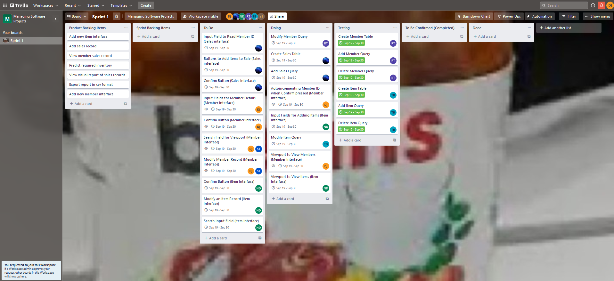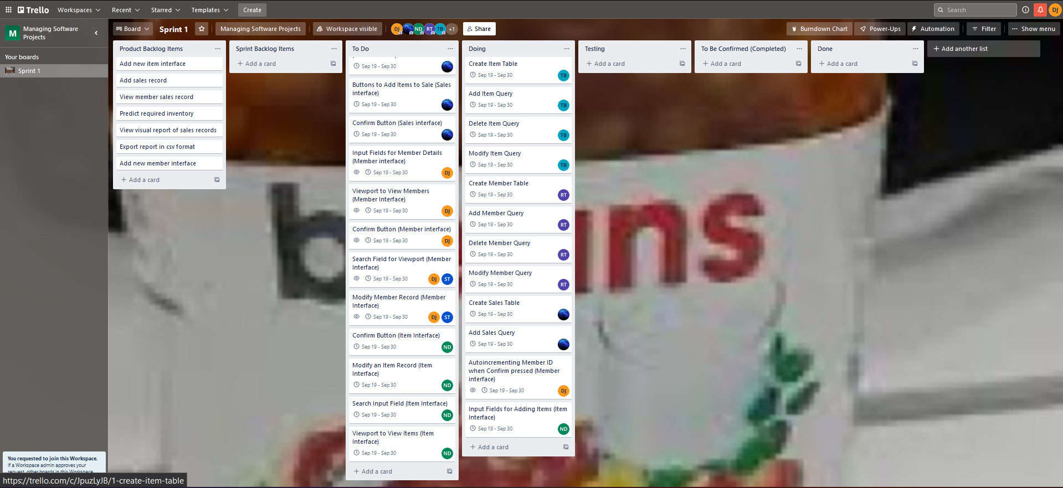There is some overlap with the master document outlining progress, however we were consistent in updating the Trello board to capture ongoing progress.

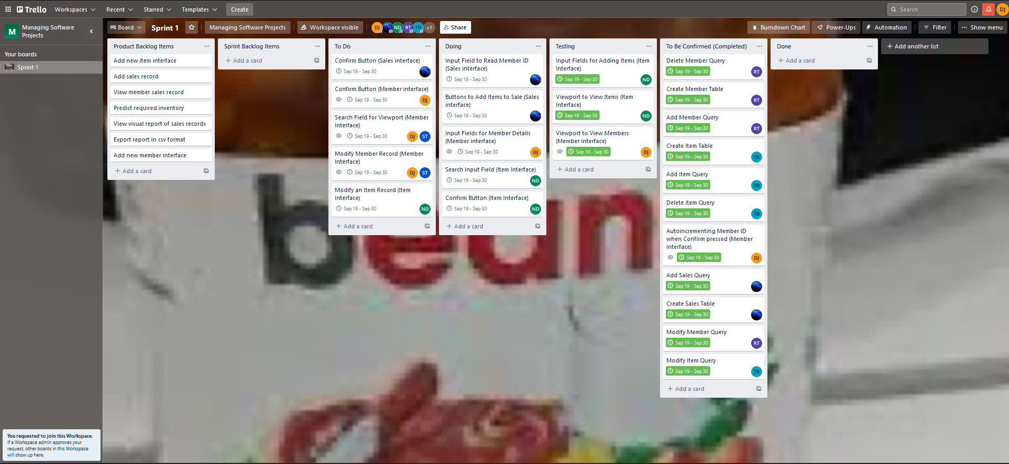

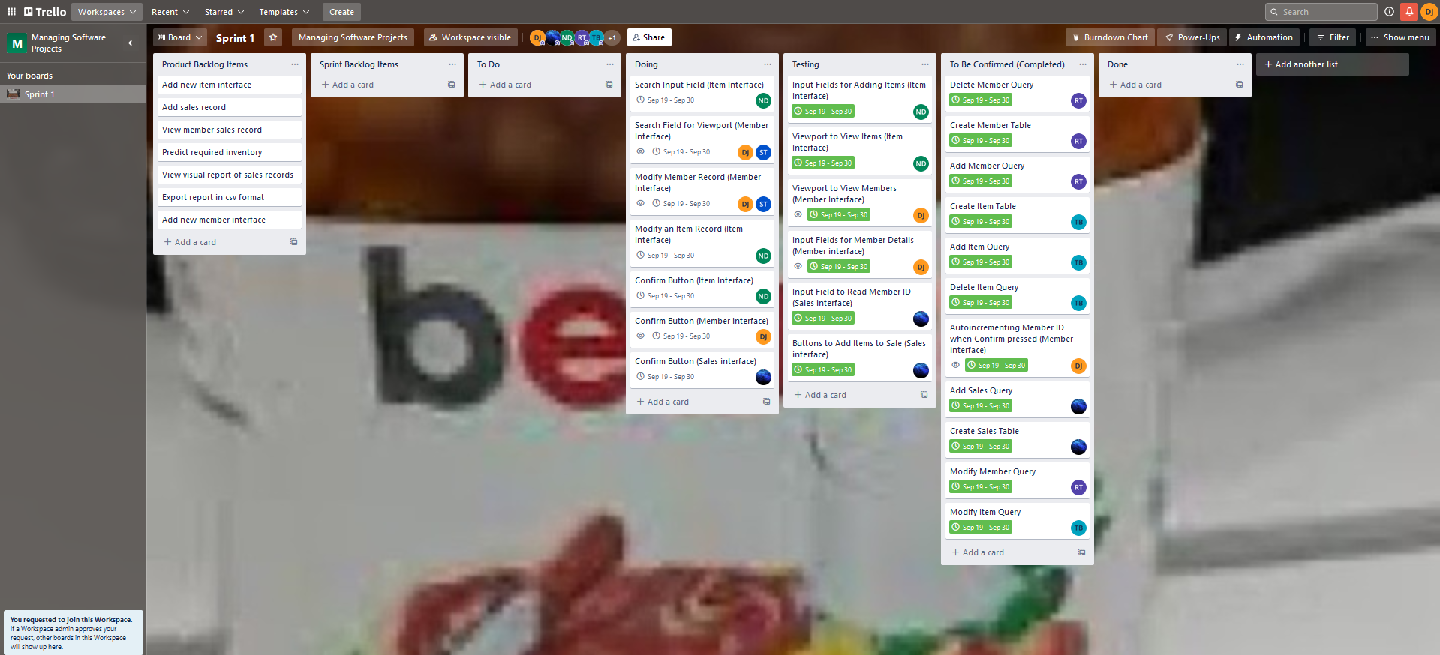

Burndown Chart Days 1-5**

As can be seen from the burndown charts, we are quickly smashing through the tasks allocated for sprint 1 in the product backlog. Though most of the tasks are completed in a single day, there have been a few which haven’t. Ideally these should be split into smaller subtasks, but they are still relatively simple and so we decided against splitting them.

**Group Meeting Notes**

The group meetings were conducted over discord and involved basically checking in with each member and their given tasks to discuss if they had completed it, needed more time, or needed more help. The image below summarises the content discussed over the first 5 days:

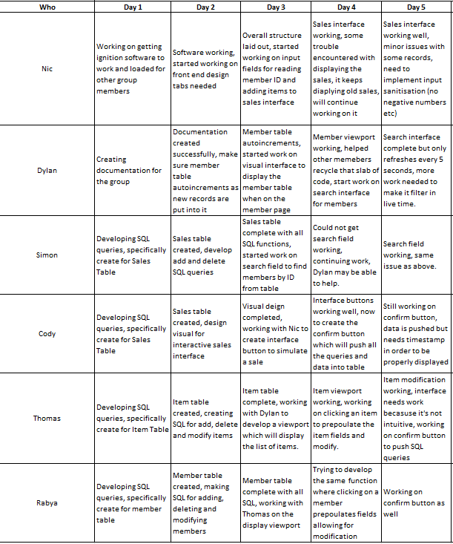

**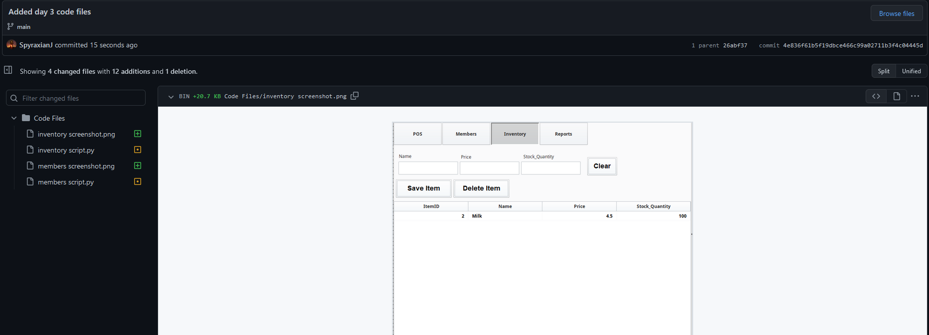****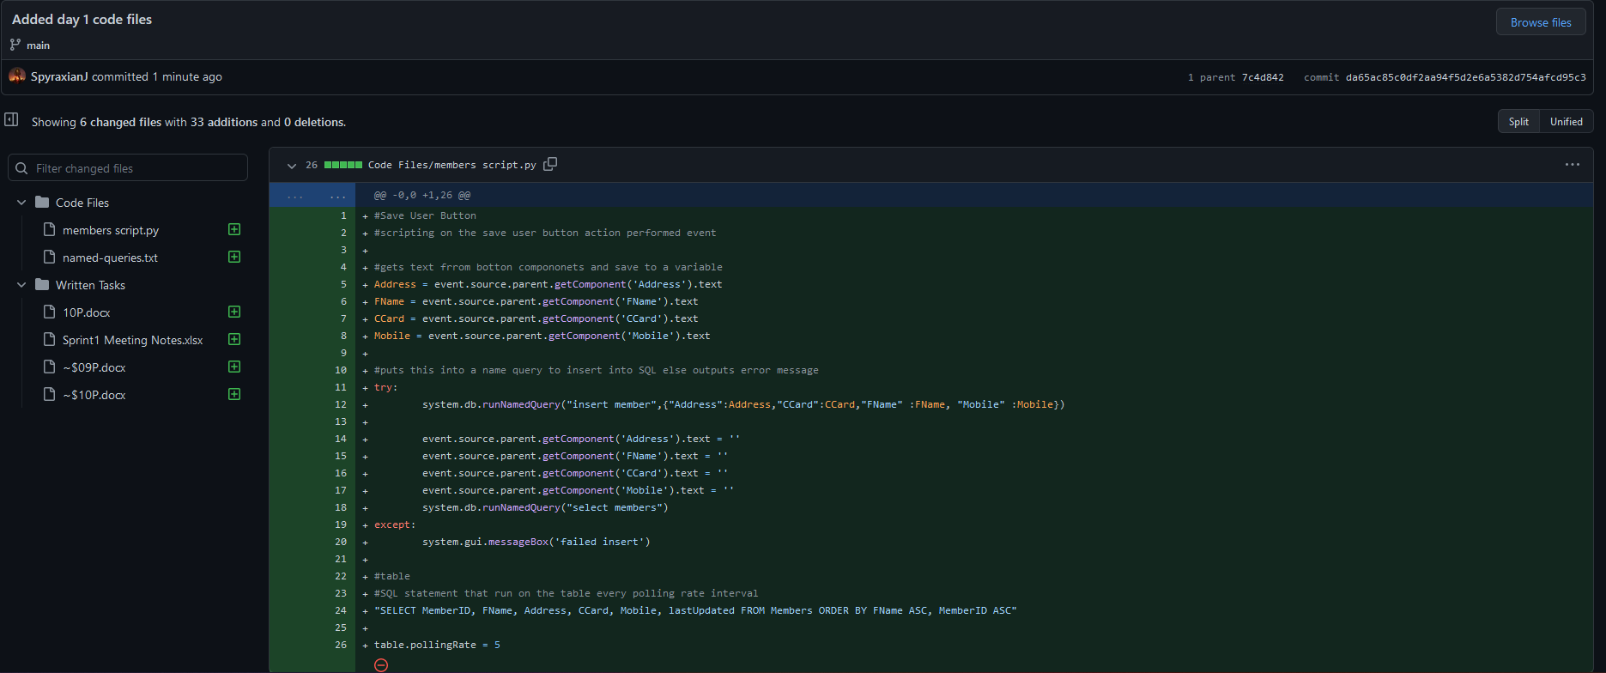**Github Repository Days 1-5**

